Exposure Java | Lab 12a
The Magpie-Chatbot Program  with arrays version | 80 & 100 Point Versions
Assignment Purpose:This assignment is meant to demonstrate how to use one-dimensional arrays in a class to create random responses.

In this chapter the Magpie program was reviewed. The review included an early Magpie version, which provided one of four random responses, if "negative" or "family" responses were not applicable. The random responses can be increased, and using the same response as the original program, any increases require additional if..else statements. With the introduction of arrays, it is more convenient to store random responses in a String array.

The Student Starting version, shown below, shows the Magpie class as it was provided in the review section. For this lab assignment two of the current features need to be altered and implemented with an array data structure.

Lab12ast Student Version | Do not copy this file, which is provided.
// Lab12avst.java This is the student starting version.
// This assignment pertains to some of the "Magpie" AP Lab Materials
//***************************************************************************
// The "Magpie" AP Lab is created for the College Board APCS
// curriculum by Laurie White.
// Leon Schram has altered some of the "Magpie" files to focus on
// specific CS topics as the "Magpie" Lab is integrated into the curriculum.
import java.util.Scanner;
public class Lab12avst
{
public static void main(String[] args)
{
MagpieLab12a maggie = new MagpieLab12a();
System.out.println (maggie.getGreeting());
Scanner in = new Scanner (System.in);
String statement = in.nextLine();
while (!statement.equals("Bye"))
{
System.out.println (maggie.getResponse(statement));
statement = in.nextLine();
}
}
}
class MagpieLab12a
{
public String getGreeting()
{
return "Hello, let's talk.";
}
public String getResponse(String statement)
{
String response = "";
if (statement.indexOf("no") >= 0)
{
response = "Why so negative?";
}
else if (statement.indexOf("mother") >= 0
|| statement.indexOf("father") >= 0
|| statement.indexOf("sister") >= 0
|| statement.indexOf("brother") >= 0)
{
response = "Tell me more about your family.";
}
else
{
response = getRandomResponse();
}
return response;
}
private String getRandomResponse()
{
final int NUMBER_OF_RESPONSES = 4;
double r = Math.random();
int whichResponse = (int)(r * NUMBER_OF_RESPONSES);
String response = "";
if (whichResponse == 0)
{
response = "Interesting, tell me more.";
}
else if (whichResponse == 1)
{
response = "Hmmm.";
}
else if (whichResponse == 2)
{
response = "Do you really think so?";
}
else if (whichResponse == 3)
{
response = "You don't say.";
}
return response;
}
}

80 Point Version Specifics

For the 80-point version you need to rewrite the getRandomResponse method so that there will now be 10 different random responses. Each one of the responses is a String object in a static array. You can create your own random responses. The sample output shows the format, but due to randomness and because you create your own responses, your output will not be identical.

80 Point Version Output

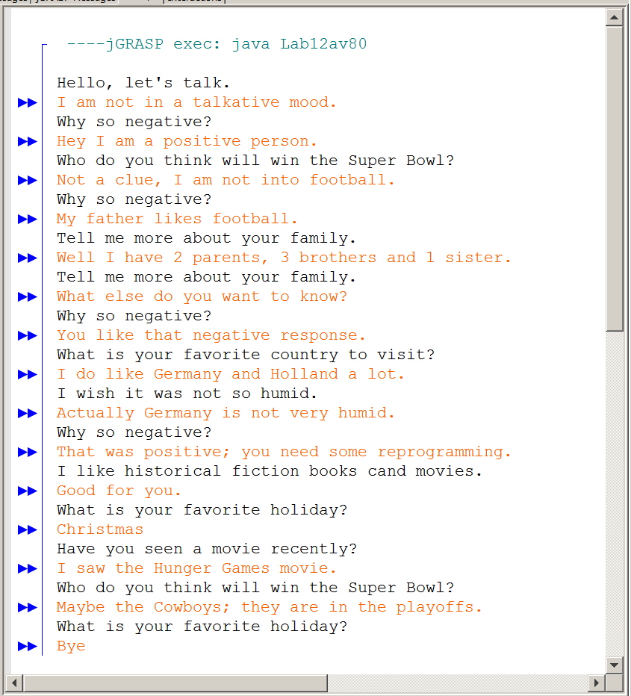

100 Point Version Specifics

The 100-point version requires improving the "family" response. Currently, the only response is Tell me more about your family. You need to create 10 responses that need to be stored in a dynamic array. These responses are also randomly given, but only for family-type input. Add "family" and "parent" to the statements that use the family response.

100 Point Version Output

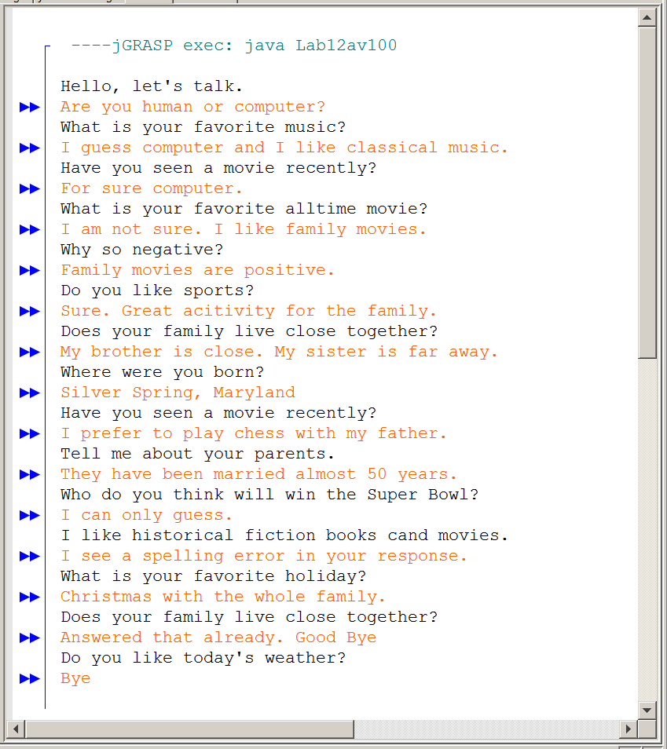
You are intentionally told to use both a static and a dynamic array for this assignment. The requirements are similar and in both cases the arrays are used for a random response. What do you think. Is the static array better for this purpose or the dynamic array? They both do the job, but for you as the programmer, what do you prefer? Think about it. It will be a class discussion topic after the lab assignment is finished.

